Spring Boot Crud Application – beta version 1.0.3

Περιεχόμενα

Figure 1 showCreate page i.e. add values to the existing database or go to DisplayAllData page 2

Figure 2 DisplayOwners page i.e. display all the values of the database (except for the password) 2

Figure 3 ShowUpdate page i.e. update the values of the db for id=1 (Figure 2, row 1, Update button) 3

Technical Requirements

* Java SE 1.8 or newer
* Database: MySQL > 5.5 → Hibernate
* Spring Boot, Spring MVC, Spring Security
* Maven
* FreeMarker Template (FTL)
* Javascript/JQuery
* VCS: Git (Gitlab repositories)

[GitHub Repository](https://github.com/AlexandreLeFou/SpringBoot.git)

$ git clone https://github.com/AlexandreLeFou/SpringBoot.git

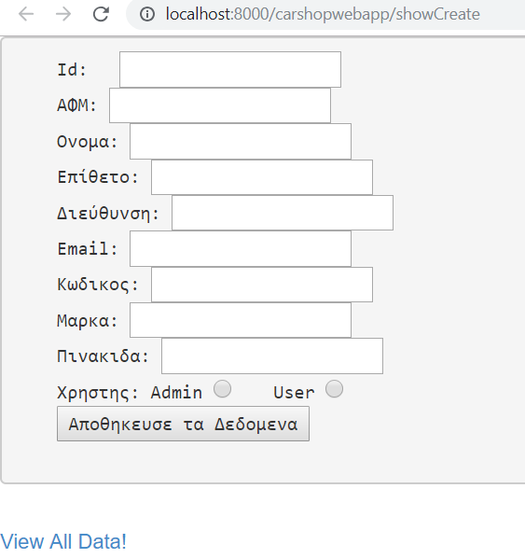

## Figure 1 ShowCreate page i.e. add values to the existing database or go to DisplayAllData page

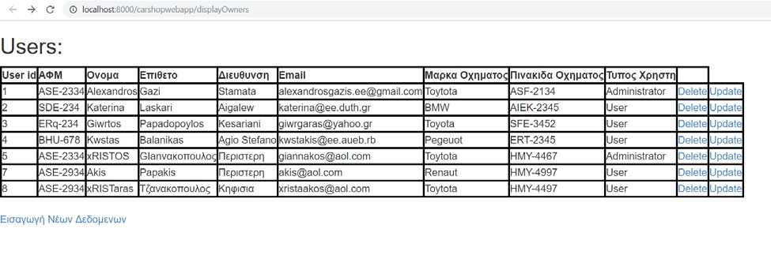

## Figure 2 DisplayOwners page i.e. display all the values of the database (except for the password)

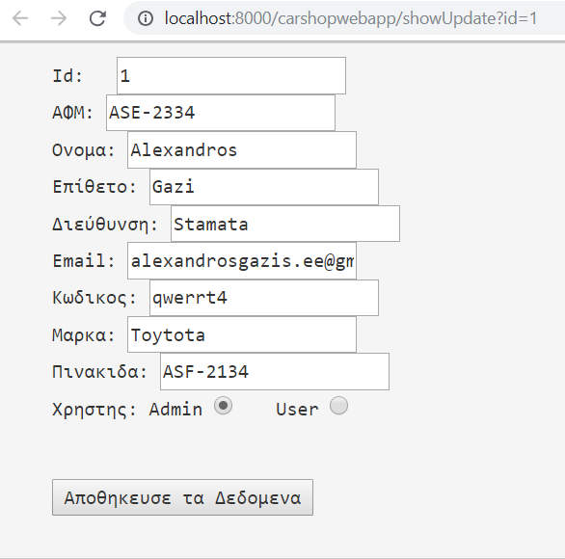

## Figure 3 ShowUpdate page i.e. update the values of the db for id=1 (Figure 2, row 1, Update button)

*It is noted that the id cannot be altered and that ONLY when selecting update, the field of the User/Admin the password field of the db is presented.*

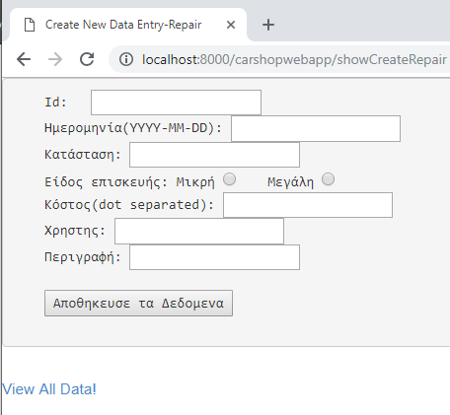

## Figure 4 ShowCreateRepair page i.e. add values to the existing database or go to DisplayRepairs page.

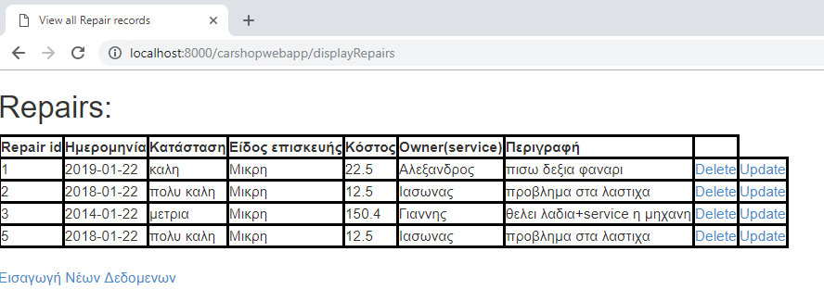

## Figure 5 DisplayRepairs page i.e. display all the values of the database

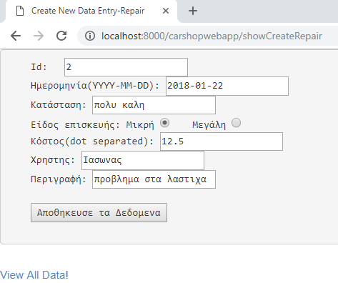

## Figure 6 showUpdateRepair page i.e. update the values of the db for id=2 (Figure 5, row 2, Update button)

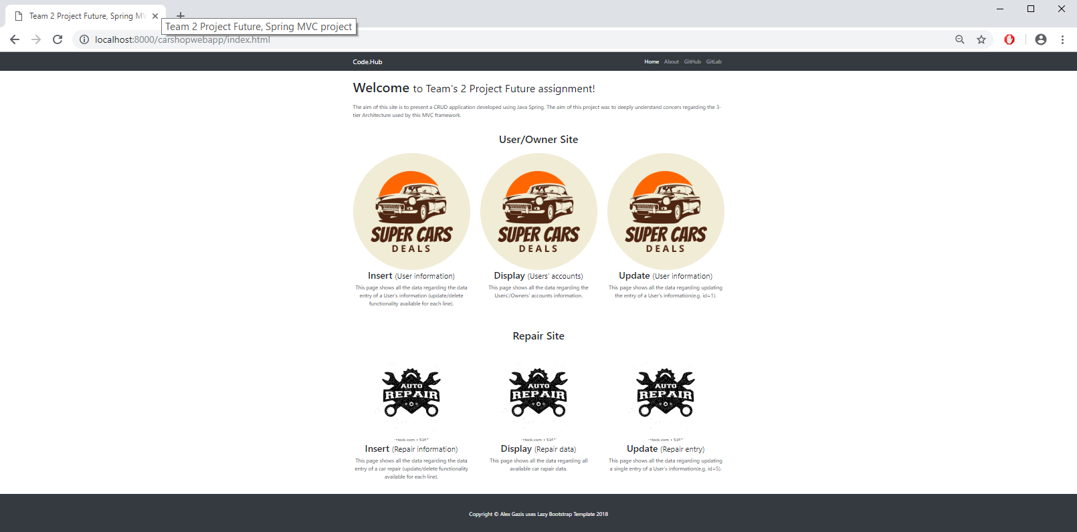

## Figure 7 The main(index) page regarding the web application